**LOGISTIC RIGRESSION**

**Business Problem** = ﻿ ﻿Prepare a prediction model Whether political candidate wins an election

(0-win,1-loss)

* **Name of the File: -** election_data.csv
* **Size of the File: -** 228 bytes
* **Data: -** 10 Observation, 4 Variable

**Exploratory data Analysis** =

* **Outliers: -**  Outliers are not presents.
* **Missing Value: -** Data don’t have Missing Values
* **Normality: -** Data are not normal
* **Output:** - Binary

1. Measuring Percentage of win and loss in output columns

**Win** - 40 %

**Loss** – 60 %

**Model Building on Train Data = ﻿**Building model after removing year due to multi-collinearity problem.

* **Summary: -**

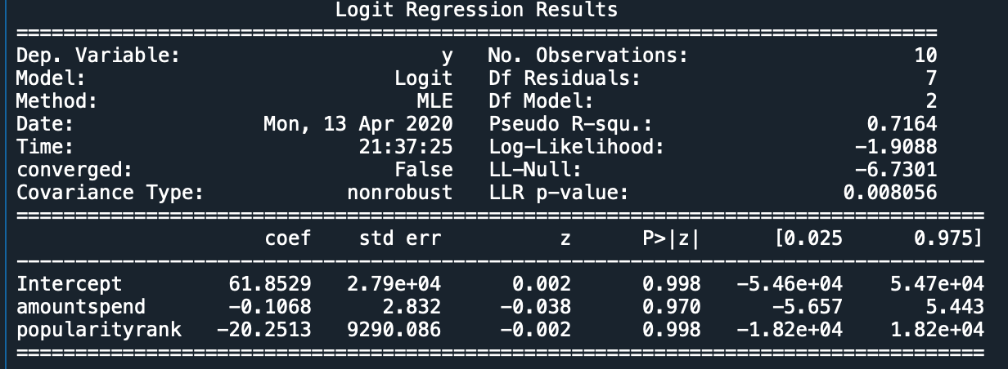

* **AIC: -** ﻿9.8
* **﻿Accuracy :-** 90 %
* **﻿Sensitivity :-** 75 %
* **﻿Specificity: -** 100 %
* **No observation: -** 10
* **﻿Df Residuals:** - 7

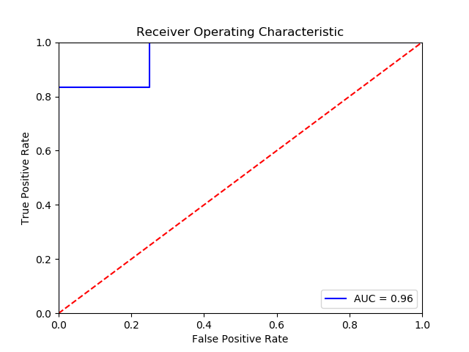**Roc Curve**: -

**Roc Curve**: - 96 %

**Python code file**: - [Election Analysis.py](https://github.com/nilaydeshmukh0/Logistic-Regression-With-EDA/blob/master/Election%20Analysis/Election%20Analysis.py)